Assignment 1 — Data Visualization Report
Student Performance Dataset Analysis

1. Introduction
This report presents an exploratory data analysis of the Students Performance dataset. The goal is to understand how demographic and preparation factors influence student performance across math, reading, and writing subjects using visualizations.

2. Data Preprocessing
The dataset was cleaned and prepared for analysis. Column names were standardized, and derived metrics such as average score were computed. Missing values were checked and handled appropriately.

3. Visual Analysis
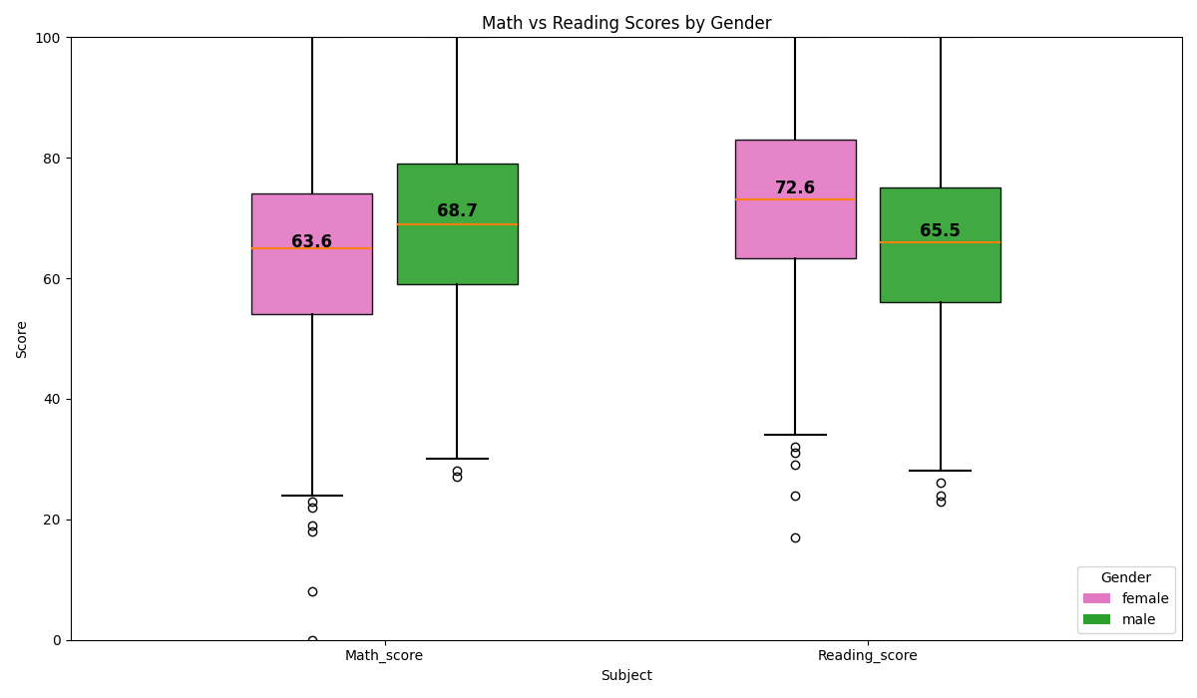
Figure 1: Math and Reading Scores by Gender
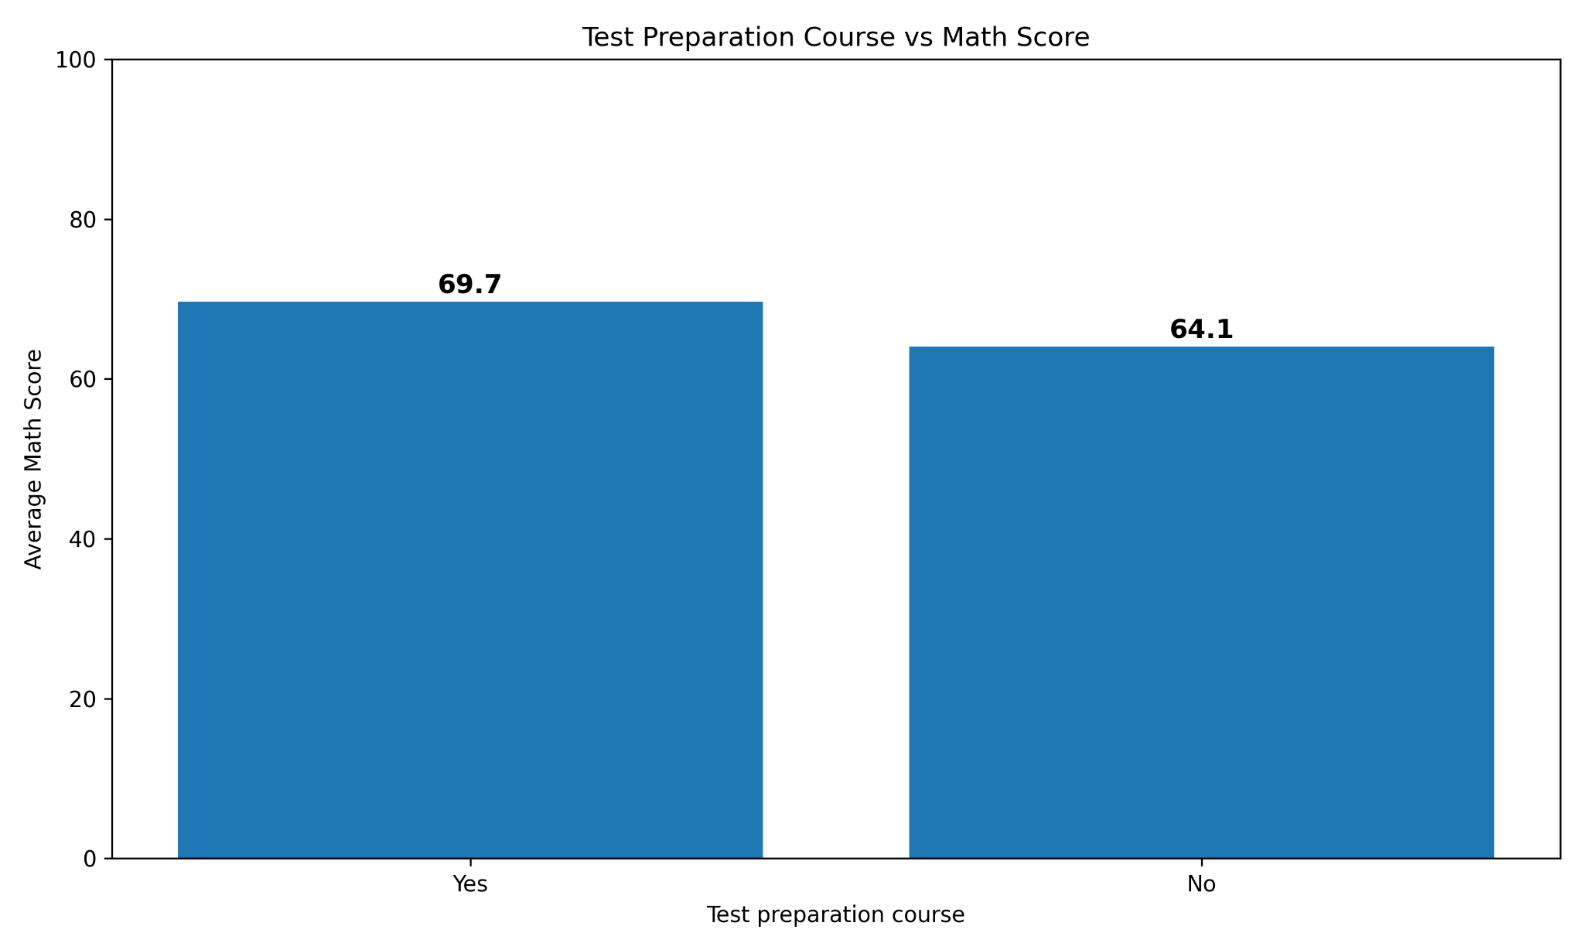
Figure 2: Test Preparation Course Impact on Math Score
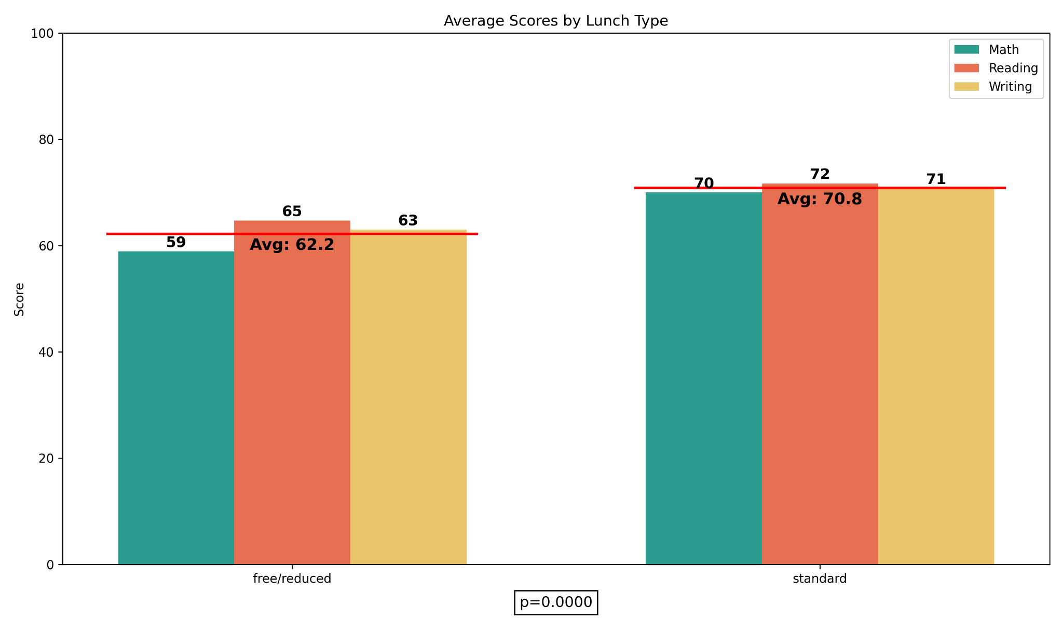
Figure 3: Average Scores by Lunch Type
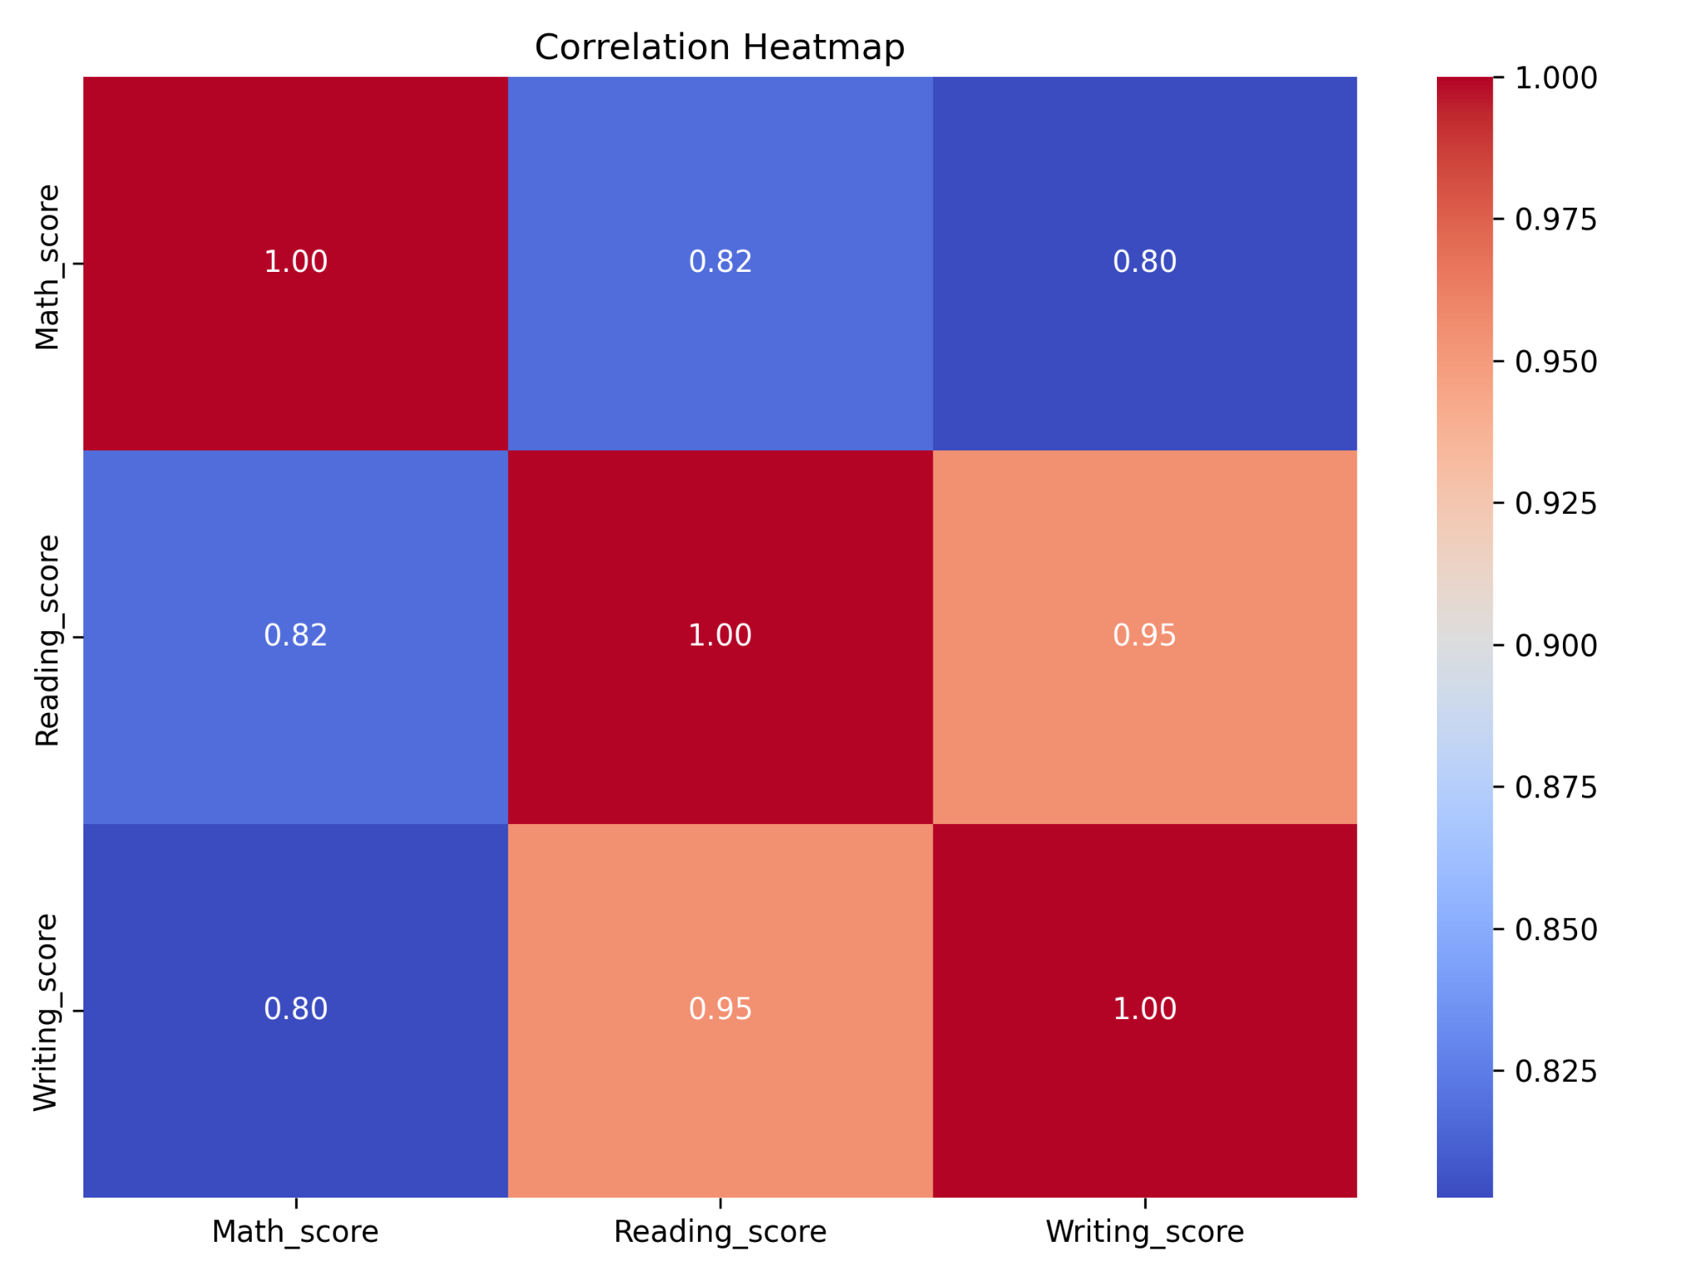
Figure 4: Correlation Heatmap
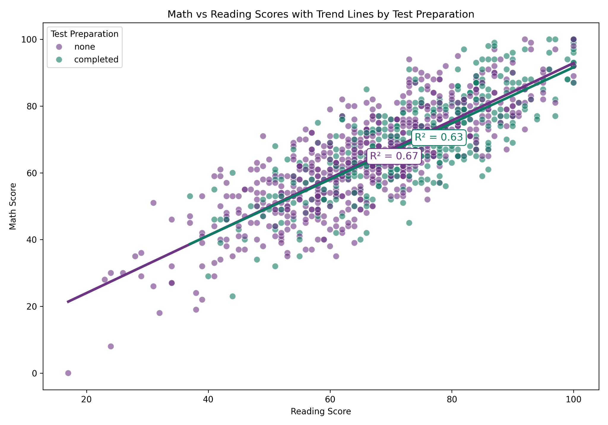
Figure 5: Math vs Reading Scores with Trend Lines by Test Preparation

4. Findings
The visualizations reveal several key insights:
- Students who completed the test preparation course generally achieved higher scores.
- Students with standard lunch tended to perform better across all subjects compared to free/reduced lunch.
- Strong positive correlations exist between math, reading, and writing scores.
- Gender differences are present but not as pronounced as preparation and socioeconomic indicators.

5. Conclusion
Overall, preparation and socioeconomic factors appear to have a meaningful impact on academic performance. The results highlight the importance of access to resources such as preparation programs and adequate nutrition in improving educational outcomes.

